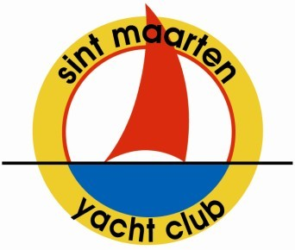
Sint Maarten Yacht Club
90 Welfare Road, Simpson Bay Bridge,
P.O. Box 5315 Philipsburg, ST. MAARTEN Tel: +1 (721) 5442079
Email: manager@smyc.com
ww.smyc.com
St. Maarten Heineken Regatta Email: regatta@heinekenregatta.com www.heinekenregatta.com

APPLICATION FOR TEMPORARELY MEMBERSHIP
PLEASE COMPLETE IN BLOCK CAPITALS.

INDIVIDUAL MEMBERSHIP APPLICANT
First Names/s:

Surname:
Date of Birth:

ADDRESS OF MAIN RESIDENCE
IN CASE OF EMERGENCY

First Names/s:

Surname: Title: Mr: Mrs: Miss: Ms. Other:
Date of Birth:

Children under 18 years
Name: M / F Age:

M / F Age:
M / F Age:

Email
Boat usage for SMYC members Waiver
User (fill in member name)
…………………………………………… hereby borrows from SMYC:
(fill in boat name) ……………………………...
complete with sail, to be used for:
(fill in event and date)
……………………………………………………

The user hereby assumes all risk of injury to any person or property from any cause whatsoever in connection with the possession and use of the aforementioned boat.
User hereby indemnifies and holds the SMYC harmless from any claim, action, proceeding, damages and liabilities,
including reasonable attorney’s fees and court costs, arising from or in connection with the possession, use and return of the boat used.
User shall maintain the boat clean and presentable and in the same condition as accepted at the beginning of use. In case of damage not implicative to "age" of the equipment, the user shall cover the costs for the repair.
User hereby assumes all risk of loss and damage to the boat. In the case of a collision the user is responsible to pay for damages, even if it is not their fault.

Sint Maarten, date ……………………………..

Name:

Signature:

Parent signature (for minors)
Tel: Cell:

Please give details of Membership of hometown Yacht Club:

APPLICANT
Signature Date of Application

We wish to provide you with the information you want from the club. The answers you provide will be used to get the right information to you and in the format you want. All the answers you give will be treated in the strictest confidence and will not be passed to any other organization.

FOR OFFICE USE ONLY:
Date Received: Date Approved:
Date Notified: Member Category: Initiation Fee: Date Paid: Yearly Dues: Date Paid: Signed:

